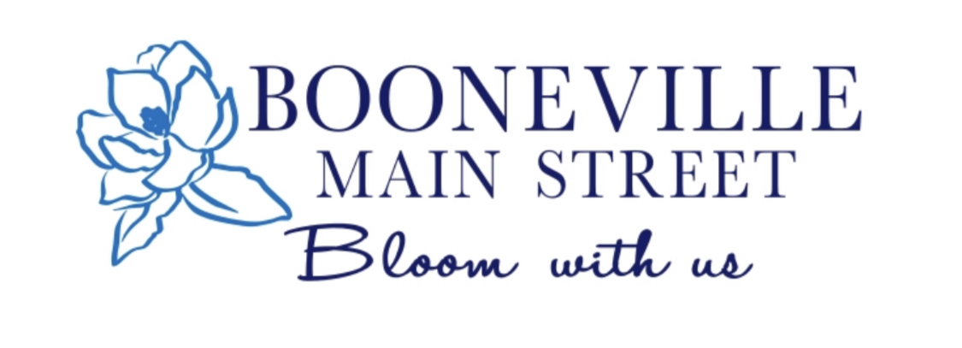
2022 Partnership Application

Business Name:_______________________________________________________
Contact Name:_________________________________________________________
Physical Address:_______________________________________________________
Mailing Address(if different):_______________________________________________
City:_____________________State:________________Zip Code:_________________
Phone:_____________________________Email:______________________________
Website:_______________________________________________________________
Social Media:
:___________________________ :__________________________________
:___________________________ :__________________________________
Partnership Dues

Please select the fee that applies
- $50 (Individuals/Couples)
- $75 (Church/Civic Club)
- $100 (Up to 4 Employees)
- $175 (5-100 Employees)
- $350 (101-200 Employees)
- $500 (201+ Employees)

Payment Information

Amount:______________________Cash/Check# ______________________
Date of Payment_______________________
Signature of Business owner:_______________________________________
Return Address: 100 W Church Street Booneville, MS 38829
If you have any questions, please call 662-322-6402 or email
ltucker@booneville-ms.gov

How do you want to be involved in 2022?

Participate:

Spring Open House _______
Hospitality Arts Festival ______
Tailgate Ladies Night Out/ Open House ________
Block Party______
Fall Festival_______
Christmas Open House_____
Christmas Parade________

Sponsor:

Mural Project ______
Hospitality Arts Festival ______
Screen on the Green_____
Block Party______
Fall Festival_______
Membership Dinner_____
Christmas Parade______

Volunteer:

Membership Drive ______
Hospitality Arts Festival ______
Block Party_____
Fall Festival_____
Membership Dinner_____
Beautification/ARTS ______
Christmas Parade_____

By selecting any of the above you are not committed to them. This is just to help us know who would like to participate in which event. There may be more events that you can participate, sponsor, or volunteer for throughout the year.

